Homepage and Menu Bar

The homepage follows the current style. At the very top, there's a menu bar that aligns with the frontend layout of "abdex". On the left side, it remains consistent with the current design. The focus of this update is on four pages: "Trade", "Stable Coins", "Market Making", and "Faucet". When hovering over the blank profile picture area, options to connect and create a wallet will pop up. (As shown in the image) Currently, only the "Connect Wallet" option is available, but the "Create Wallet" option needs to be added.

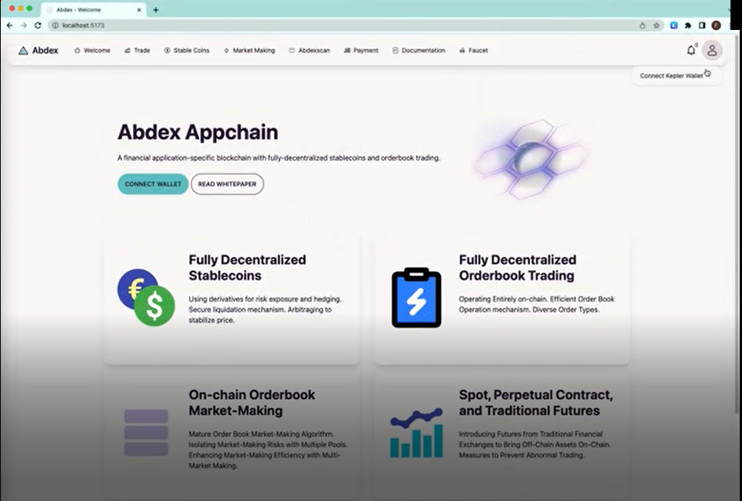

 After successfully connecting the wallet, moving the mouse over the profile picture will now display more options. Taking the Binance website as an example (shown below), with some differences: the email is replaced with the current wallet address, and a copy button is added beside it (📋). Only the three options within the red box are retained and are respectively changed to "My Assets", "My Orders", and "My Positions". Finally, the "Logout" option is changed to "Disconnect Wallet".

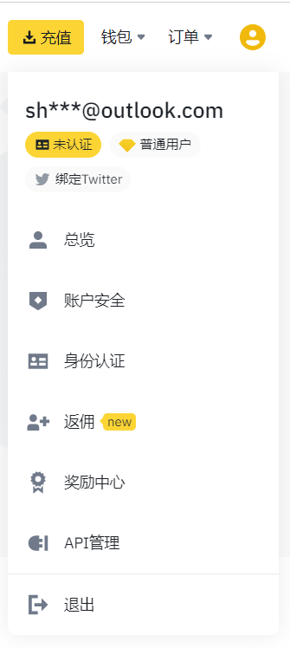

The "My Assets" page is designed with reference to the Binance spot account interface, retaining the elements within the red box. The last instance of the currency "BNB" is changed to "USDT":

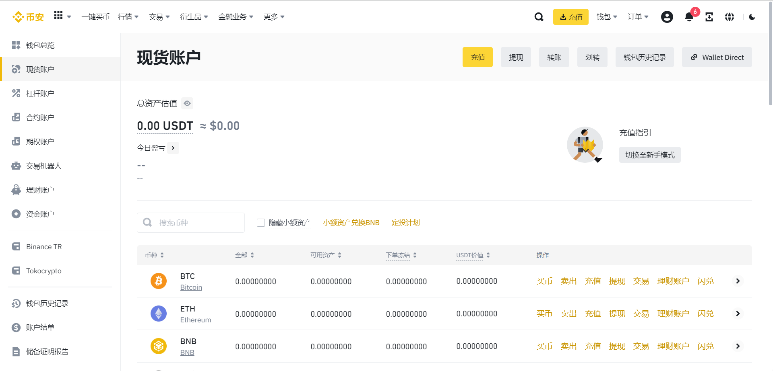

"The 'My Orders' page will have a layout consistent with the 'My Assets' page. Only the table within the red box at the bottom needs to be replaced as follows:

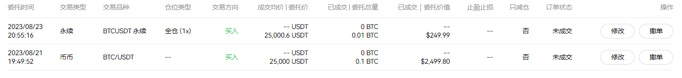

"The 'My Positions' page will have a layout consistent with the aforementioned ones. However, the table will be modified as follows. The column '业务线' will be changed to 'Trade Direction', '平仓均价' to 'Position Quantity', and '最大持仓量' to 'Maintenance Margin'. The three columns within the red box will not be included. A new column labeled 'Actions' will be added, with two buttons beneath it: 'Close Position' and 'Market Close'.

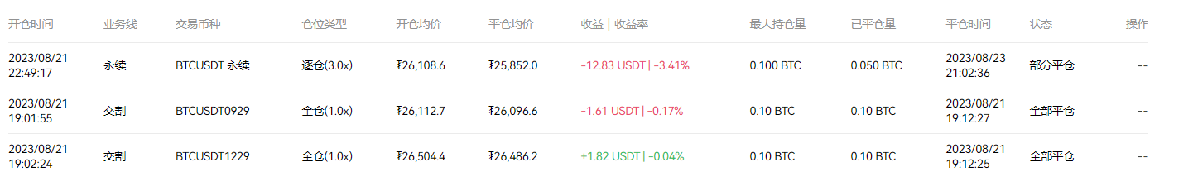

**"Trade" page**

The "Trade" page takes inspiration from OKEx, with the following layout:

* The top row displays the current market name and basic market information. For spot and futures, it includes market name, current price, and oracle price. Additionally, for perpetual contracts, it includes the current funding rate.
* On the left side, users can select different market types. At this stage, you'll implement spot, futures, and perpetual markets, corresponding to "Spot", "Futures", and "Perpetual" categories in the OKEx interface.
* The middle section contains coin information and the order placement UI.
* The right side displays the order book. The image you've referred to displays the BTC/USDT trading pair in the spot trading section of the exchange.

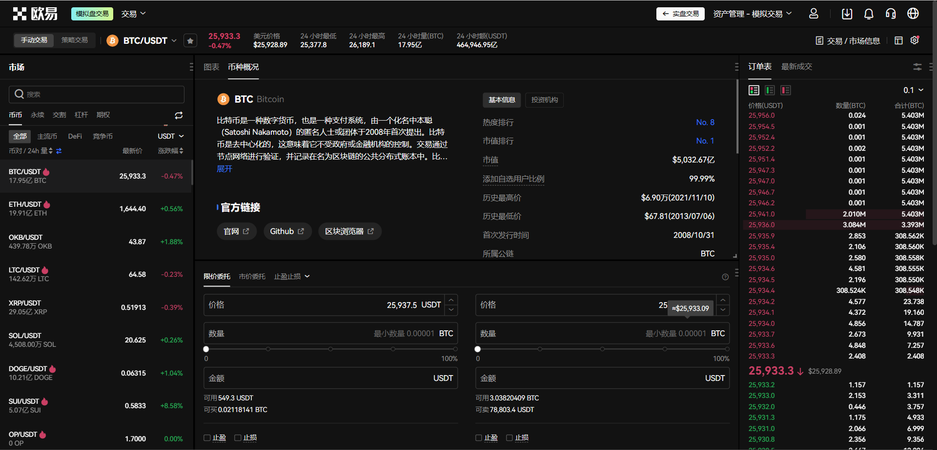

The UI for placing spot orders includes functionalities for limit orders and market orders. Stop loss/take profit functionalities are not required.

For Limit Orders, users can adjust the price and quantity. Clicking on the "Buy" and "Sell" buttons completes the operation. In the first row within the red box, "可买/可卖" is changed to "Estimated Fee". In the second row within the red box, "止盈止损" is changed to a dropdown menu. In this dropdown, "数量" is changed to "Gas Fee", and the "BTC" field provides a dropdown to select the currency, which can be BTC, ETH, or USDT.

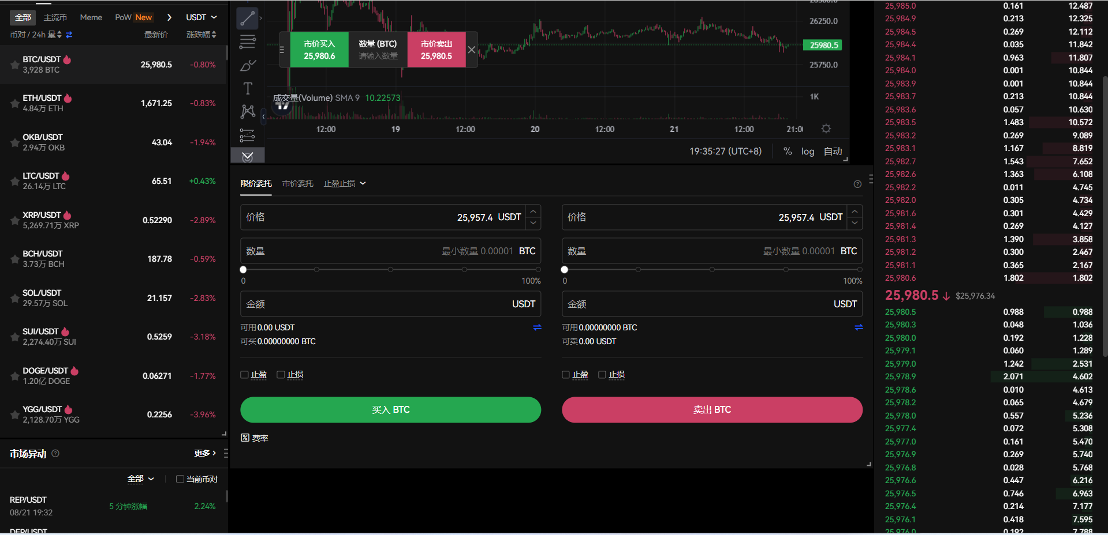

The UI for placing market orders is slightly different. Only the amount can be adjusted. Changes within the red box are consistent with the description above.

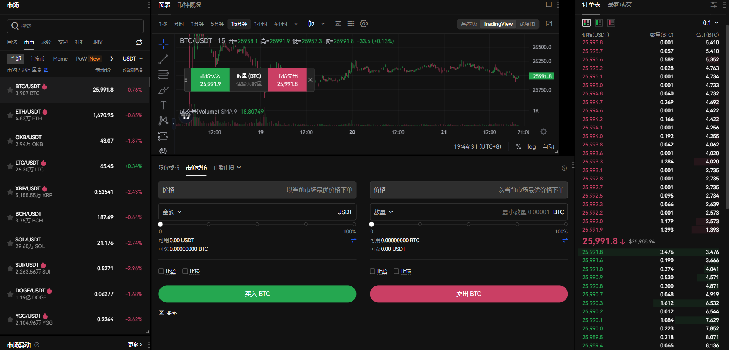

After clicking the "Buy" or "Sell" button, a confirmation dialog for order placement will pop up.

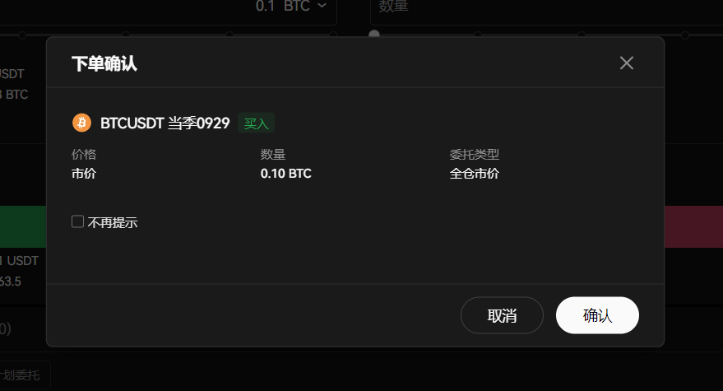

After confirming, a message will appear saying "Order placed successfully."

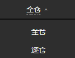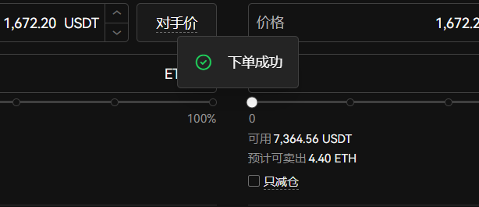

For futures and perpetual contracts, the order placement interface is as follows. Similarly, only limit orders and market orders are needed. The button labeled "对手价" in the red circle will be changed to "Cross Margin" button, and the arrow icon next to it can be changed to "Isolated Margin":

In the Market Order section, a "Cross Margin/Isolated Margin" selection button will also be added within the red circle. The content within the red box will be updated following the style mentioned above.

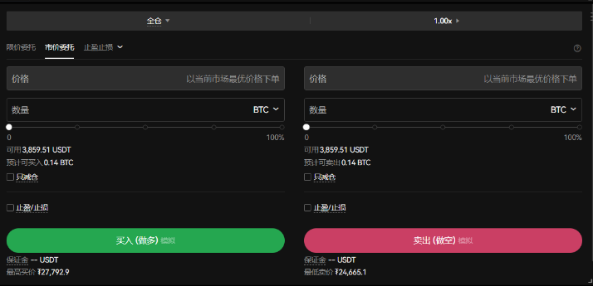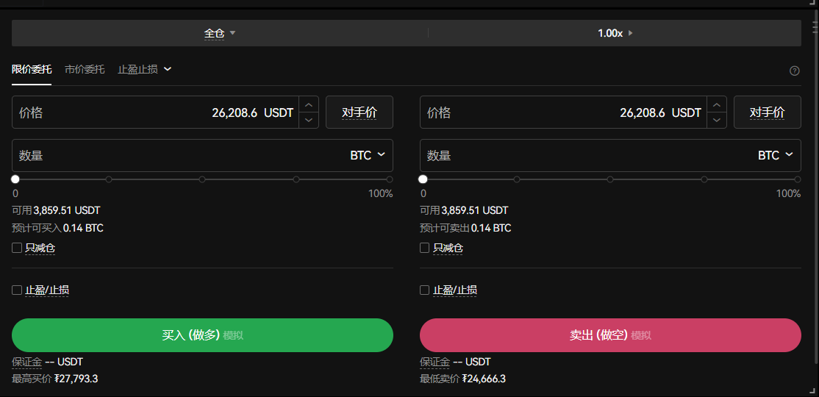

At the bottom of the trading interface, there should be the current account's trading information, including "Current Orders" (Open Orders) and "Current Positions". If there are existing orders or positions, they should be highlighted. The most recent 20 transactions are retained for each trading information.

The "Current Orders" section should include details such as order time and trade direction, similar to the table shown in the "My Orders" section of the first part. On the right side, there should be "Edit" and "Cancel" buttons:

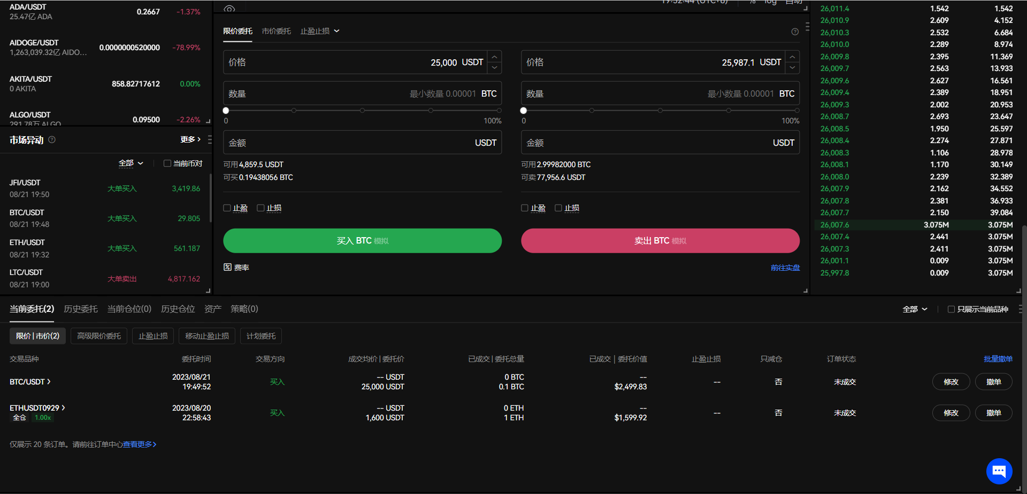

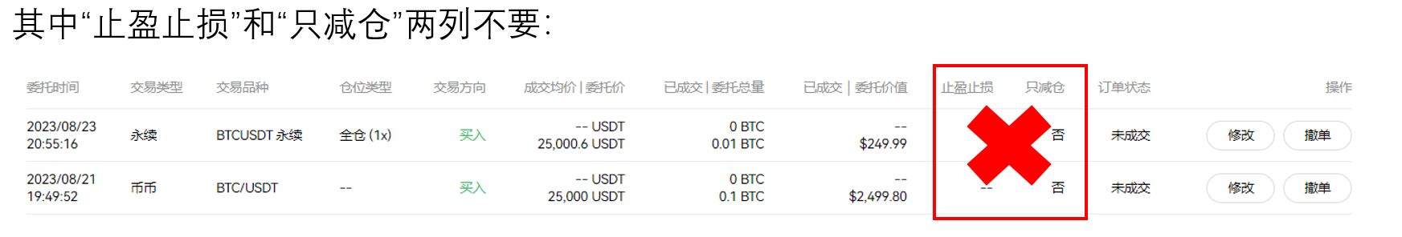

The information to be included in the "Current Positions" section is as follows. On the right side of each position, there should be two buttons: "Close Position" and "Market Close".

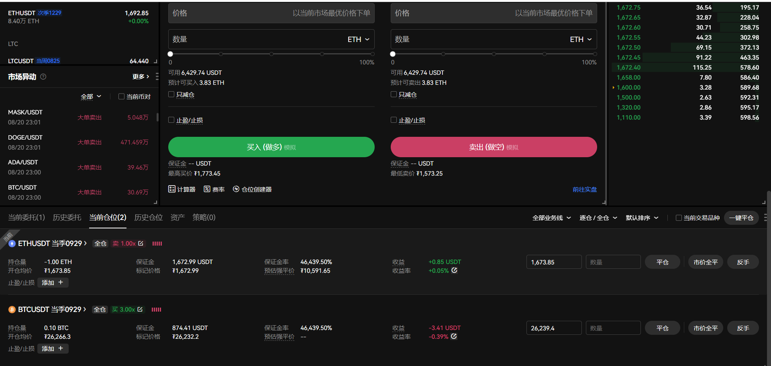

When clicking the buttons on the right side, a confirmation dialog will also appear. Taking "Market Close" as an example, the content within the red box will be retained:

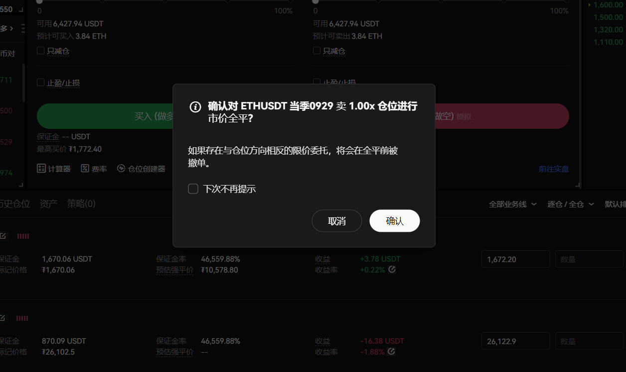

After confirming, corresponding prompts will appear such as "Modification Successful/Failure," "Cancellation Successful/Failure," and "Position Closed Successful/Failure." The style will be consistent with the "Order Placed Successfully" message mentioned above.

**稳定币界面(Stablecoins)**

The Stable Coins interface is quite simple, with the following style:

* "Buy" is changed to "Acquire."
* "Sell" is changed to "Return."
* The "I Want to Pay" on the left image is changed to "I Want to Pledge," and "I Will Receive" is changed to "I Want to Obtain." The content within the red box is changed to "Obtain Abdex Stable Coins through Overcollateralization." The "0 Fee Purchase" button is changed to "Acquire Stable Coins" button.
* On the right image, "I Want to Sell" is changed to "I Want to Return," "I Will Receive" is changed to "I Want to Withdraw," and the "0 Fee Sale" button is changed to "Return Stable Coins" button.
* After clicking the "Acquire Stable Coins" or "Return Stable Coins" button, a confirmation window should still appear, with a style similar to the one in the trading interface.

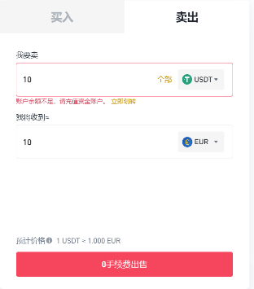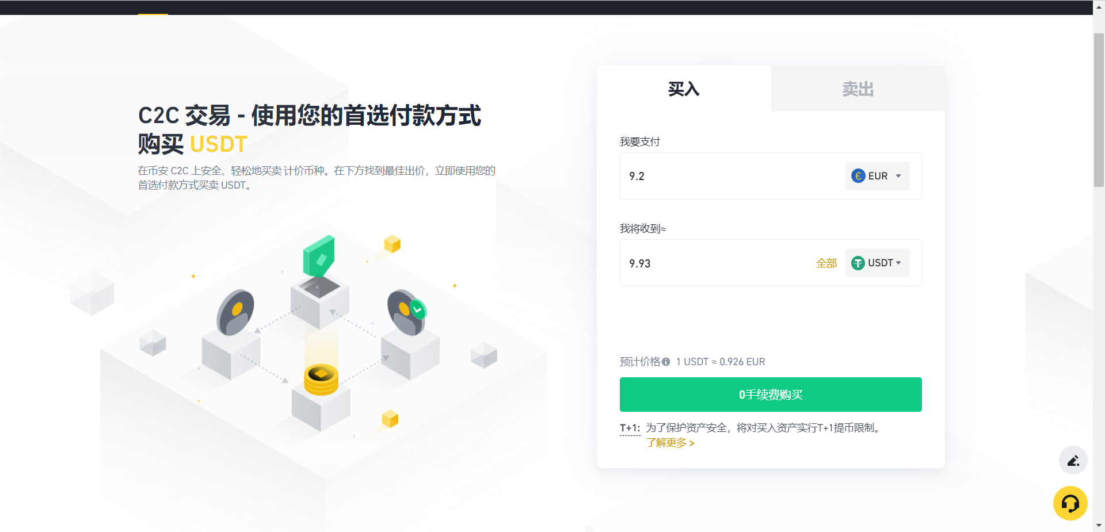

**做市界面（MarketMaking）**

The Market Making interface is designed in reference to Binance, with the following style. Only the elements within the red box are retained:

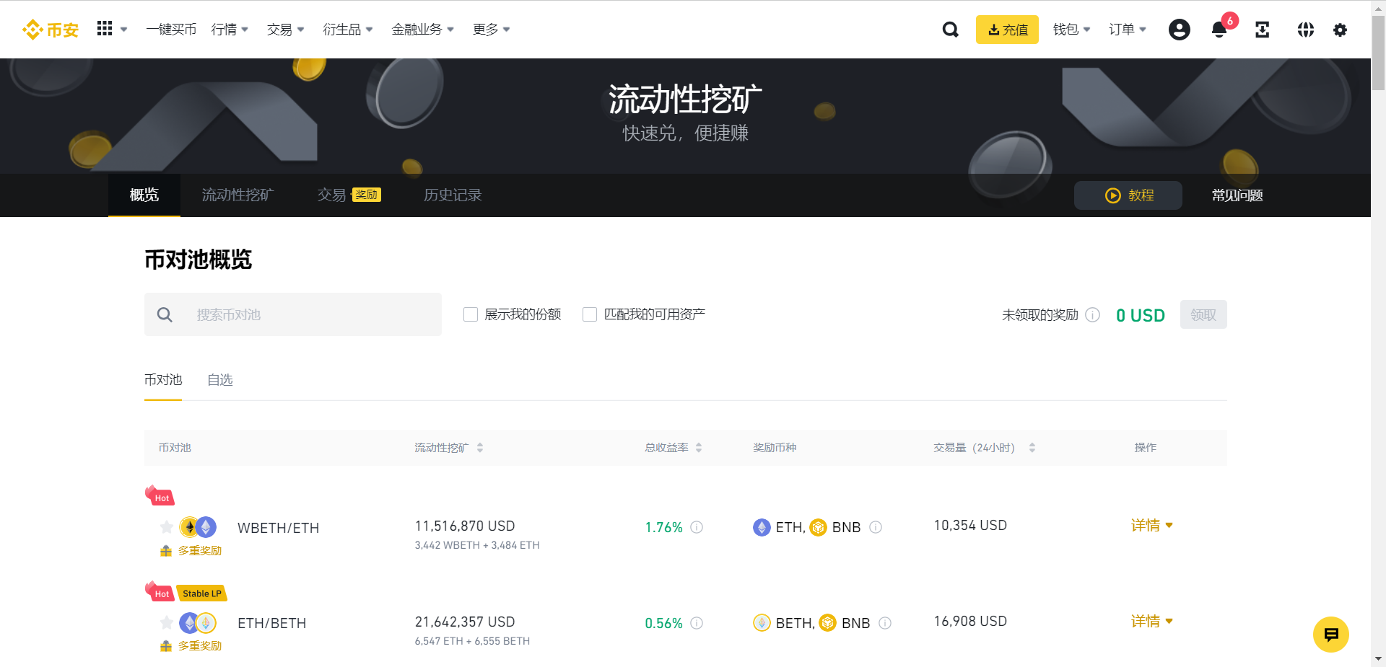

The text within the upper red box is translated as follows:

* "流动性挖矿" is changed to "Providing Funds for On-chain Automated Market Making."
* "快速兑，便捷赚" is changed to "AS High-Frequency Market Making Algorithm, Enjoy Higher Market Making Profits and Fee Sharing."

Regarding the list within the lower red box, each column from left to right is named as follows: "Funding Pool Name," "Included Markets," "Pool Currency," "Funds in Pool," "Fee Distribution Ratio," "Current Earnings," "Action."

Below the "Action" column, the "详情" text is changed to "Deposit" and "Withdrawal" buttons. When clicked, a pop-up window will appear as shown in the red box, retaining the relevant parts:

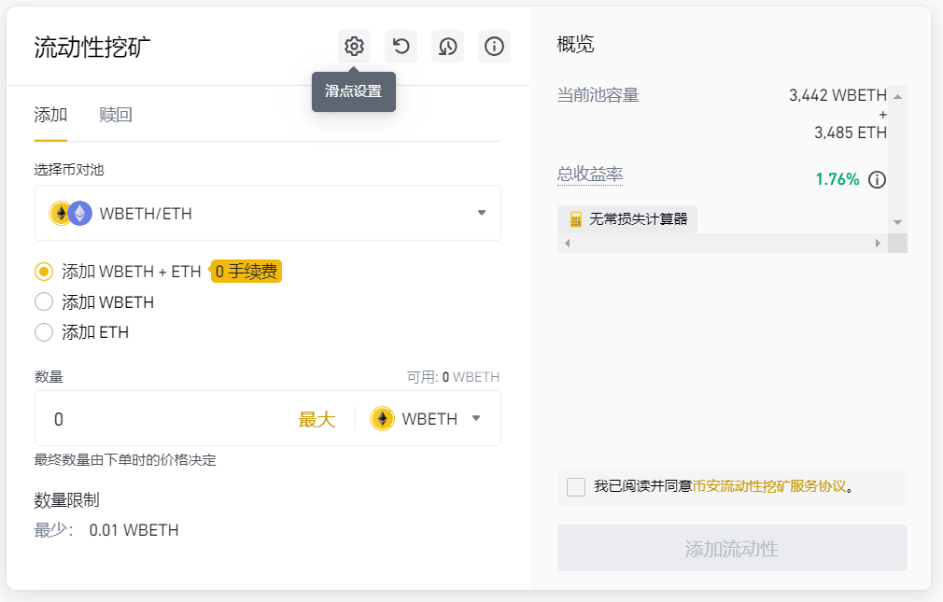

* "流动性挖矿" is changed to "Funding Pool Name."
* The toggle between "添加/赎回" is changed to "Deposit/Withdraw."
* In the third red box, the dropdown for "WBETH" is not needed; it can be fixed as the currency of that funding pool.
* The final red box contains either the "Deposit" or "Withdrawal" button. Clicking on it will trigger a pop-up message saying "Deposit Successful/Failure" or "Withdrawal Successful/Failure," similar to the previous trading module.

**水龙头界面**

The Faucet interface is simpler, following the style of any existing faucet project. For example:

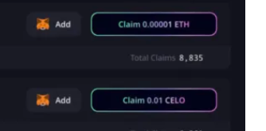

Change the small fox icon to the corresponding symbol of the coin.

additional requirements:

* The page design style and color scheme should match the light tones of the existing Abdex website.
* Start by designing the English version of the interface. If there's time, you can also work on the Chinese version
* Ensure proper integration with the backend's API.

These requirements provide a clear understanding of your preferences for design consistency, language version priority, and backend integration. When working on the project, it's important to collaborate with web designers, developers, and possibly UI/UX specialists to ensure the implementation of these requirements effectively.